J9-12 are not populated.  
  
J13 is not populated, but needs a solder jumper installed from the middle pad to the CS1 pad (on the right).

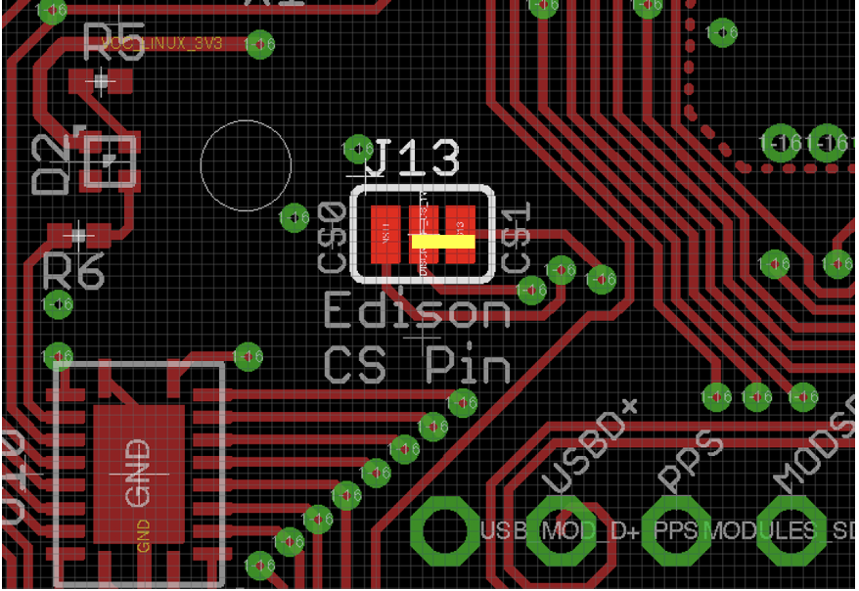

J14-15 are not populated.  
  
J4-J8 are through-hole headers. Their locations are shown in the following images.

J4 (SBH11-PBPC-D10-ST-BK) Shrouded headers are on the bottom of the board.  
NOTE: Pin one indicator on part does not align with the square pin. Instead the keyway matches the silkscreen.



J4 (SBH11-PBPC-D05-ST-BK) Shrouded headers are on the bottom of the board  
NOTE: Pin one indicator on part does not align with the square pin. Instead the keyway matches the silkscreen.



J4 (PRPC004DFBN-RC) Longer pins are on the bottom of the board



J4 (PRPC004DFBN-RC) Longer pins are on the bottom of the board  


J5 (5-146261-1) Longer pins are on the top of the board



J6 (5-146261-1) Longer pins are on the top of the board  


J7 (9-146261-0-10) Longer pins are on the top of the board



J8 (5-146261-3) Longer pins are on the top of the board

